Synopsis

Loan Default Prediction Using Machine Learning Techniques

Project Id: 2

Student Name: Khushi Kalra
Anshika Goswami
Sanskar Pandey
University Roll number : 2028445
2028392
2028484
Section-P

1. Problem Description.......................................................... 3
2. Architecture ...................................................................... 4
3. Models model..................................................................... 5
4. Evaluation metrics used.................................................... 6
5. Preliminary Results and Visualizations.......................... 7
6. References........................................................................... 8

1. Problem Description
In the banking and financial sector, predicting whether a customer will default on a loan is a critical task. Loan default can lead to significant financial losses for institutions, making it essential to identify high-risk customers before approving loans. Traditional methods rely heavily on manual assessment and basic statistical analysis, which may not capture complex patterns in large-scale customer data.
The objective of this project is to design and develop an end-to-end machine learning classification system that can accurately predict loan default using customer banking data. The system will analyze various features such as income, credit history, loan amount, and repayment behavior to identify patterns associated with default risk.
The project involves multiple stages including exploratory data analysis (EDA) to understand data distribution and relationships, data preprocessing to handle missing and inconsistent values, and feature transformation techniques such as normalization and Principal Component Analysis (PCA) to improve data quality. Machine learning models such as Support Vector Machine (SVM) with different kernels and K-Nearest Neighbors (KNN) will be implemented to perform classification.
Finally, the models will be evaluated using performance metrics such as precision, recall, F1-score, and ROC-AUC to determine their effectiveness. The goal is to build a reliable and efficient system that assists financial institutions in making data-driven decisions and minimizing the risk of loan defaults.

2. Architecture

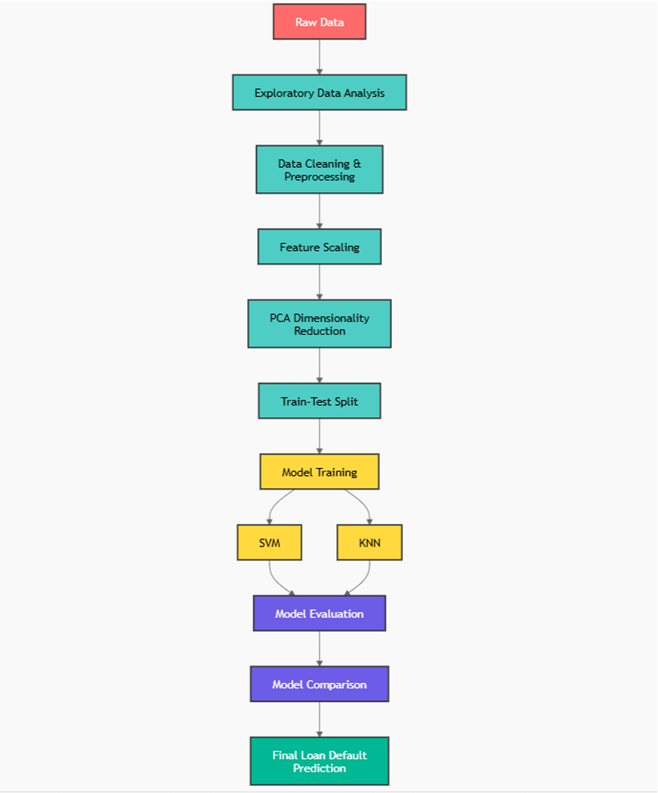

3. Models Used(Applied/ Planned)
Give a brief introduction of the models used

1. Support Vector Machine (SVM)
Support Vector Machine is a supervised machine learning algorithm used for classification tasks. It works by finding an optimal hyperplane that separates data points of different classes with maximum margin. In this project, different kernel functions such as linear, polynomial, and radial basis function (RBF) are used to handle both linearly and non-linearly separable data.

2. K-Nearest Neighbors (KNN)
K-Nearest Neighbors is a simple and effective classification algorithm that classifies data based on the majority class of its nearest neighbors. It uses distance measures (such as Euclidean distance) to find similarity between data points. In this project, KNN helps in identifying whether a customer is likely to default based on similar past customer behavior.

3. Principal Component Analysis (PCA)
Principal Component Analysis is a dimensionality reduction technique used to reduce the number of features while preserving important information. It transforms the original data into a new set of uncorrelated variables called principal components. In this project, PCA helps in improving model efficiency and reducing computational complexity.

4. Evaluation Metrics Used

1. Precision
Precision measures the proportion of correctly predicted positive cases (loan defaulters) out of all predicted positive cases. It is important when minimizing false positives is critical, such as wrongly classifying a reliable customer as a defaulter.

2. Recall
Recall measures the proportion of actual positive cases (actual defaulters) that were correctly identified by the model. High recall is important in banking to ensure that most risky customers are detected.

3. F1-Score
F1-score is the harmonic mean of precision and recall, providing a balance between both metrics. It is especially useful when the dataset is imbalanced, as it considers both false positives and false negatives.

4. ROC-AUC
ROC-AUC (Receiver Operating Characteristic – Area Under Curve) evaluates the model’s ability to distinguish between defaulters and non-defaulters across different thresholds. A higher AUC value indicates better overall model performance.

5. Preliminary Results and Visualizations

visualization of numerical coloumns
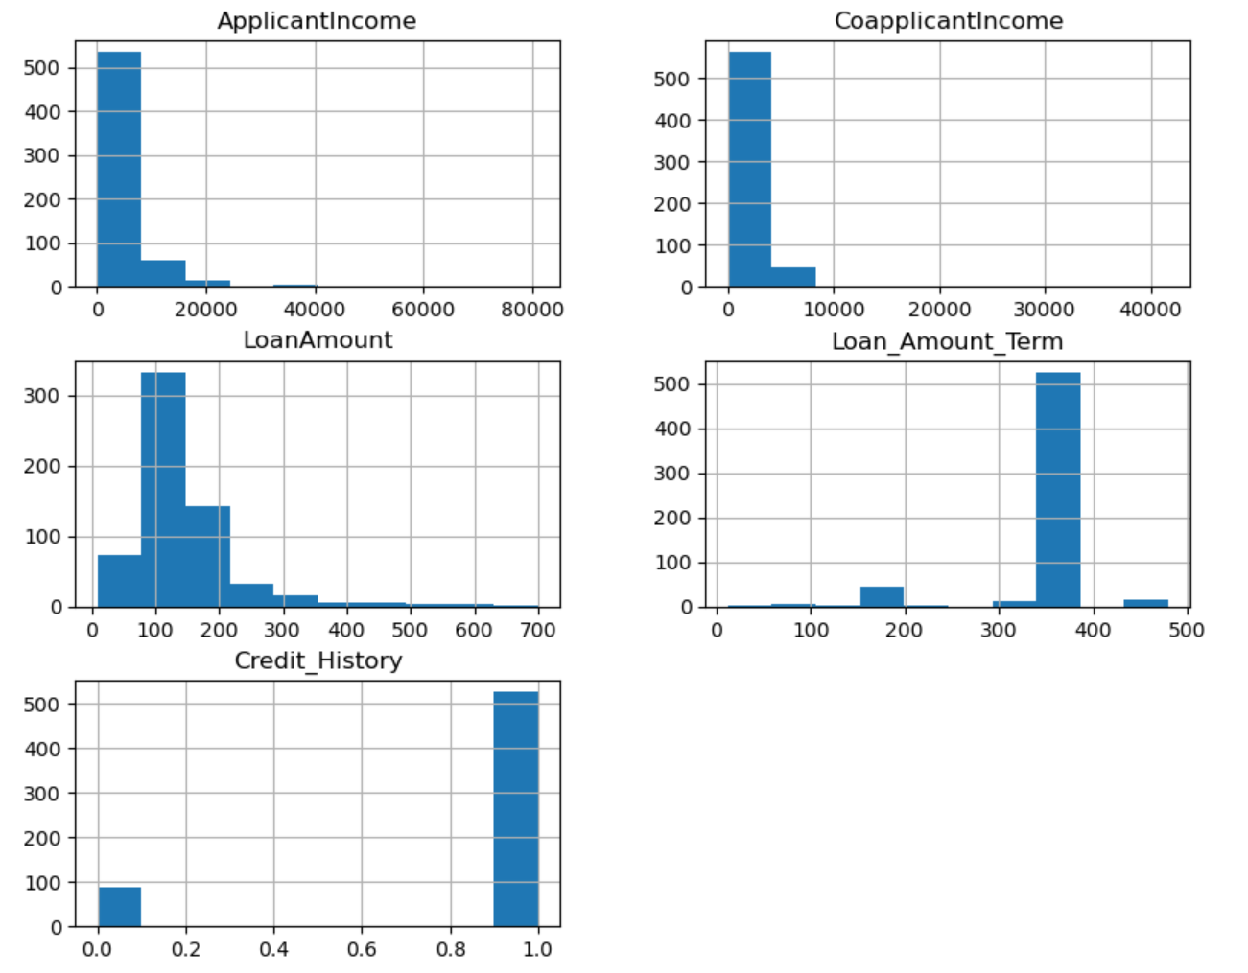
Figure: Histogram plots showing distribution of important loan dataset features.

Visualization of categorical coloumn
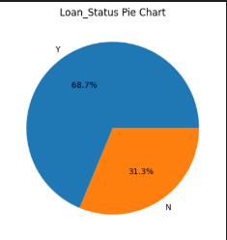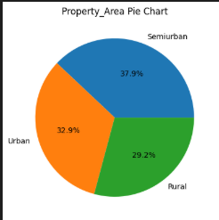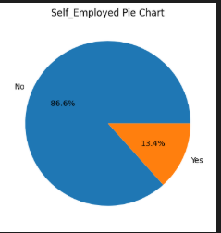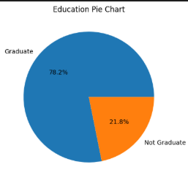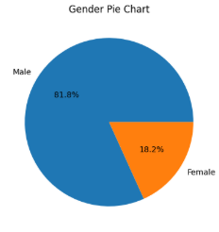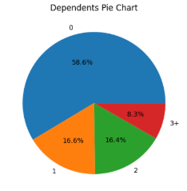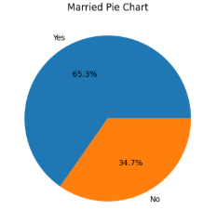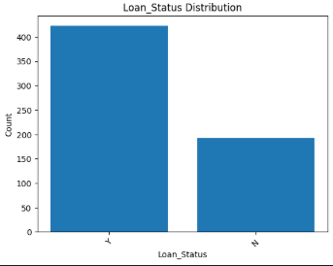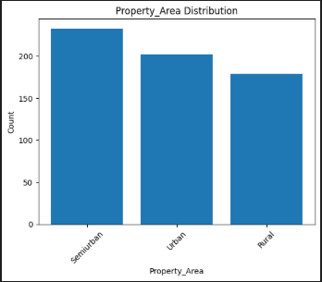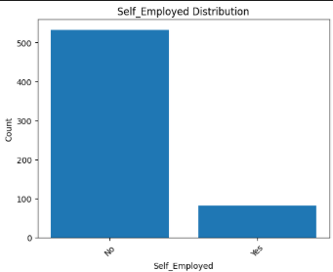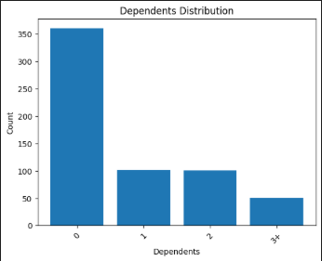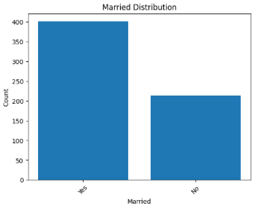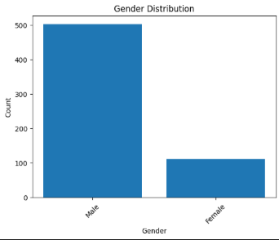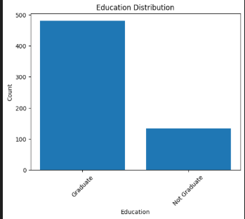

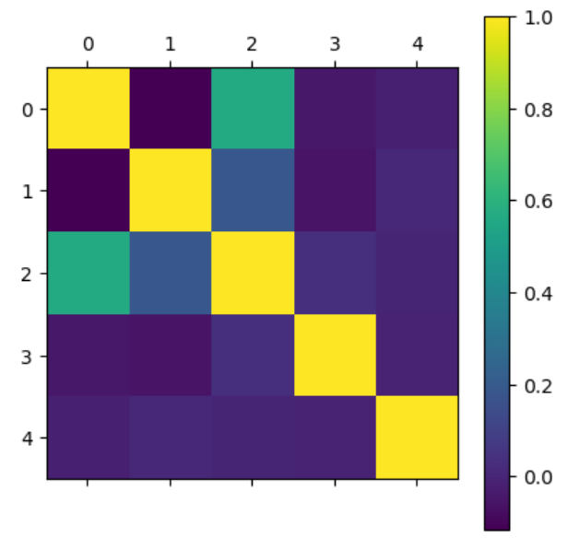
Figure: Correlation heatmap showing the relationship between different features in the dataset.

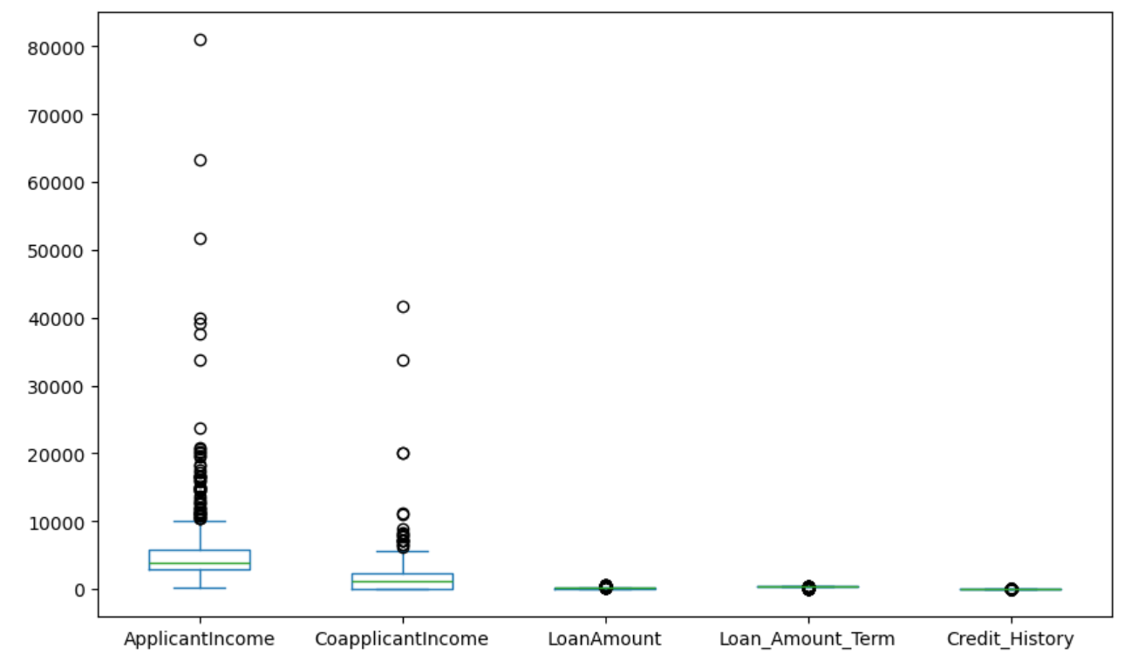
Figure: Box plots of key features showing distribution, median, and presence of outliers in the dataset.
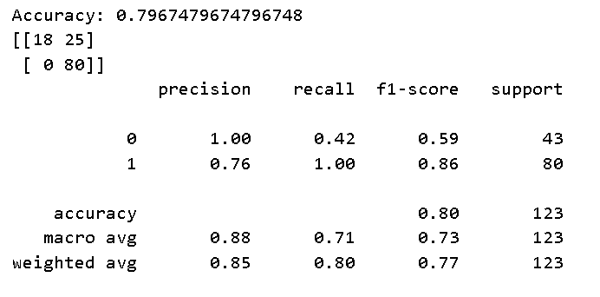
Figure: Classification report and confusion matrix showing performance of the trained model.

6. References:
- Hands-On Machine Learning with Scikit-Learn, Keras, and TensorFlow
- Introduction to Machine Learning with Python
- Scikit-learn Official Documentation
https://scikit-learn.org
- Kaggle
https://www.kaggle.com
- Towards Data Science
https://towardsdatascience.com
- GeeksforGeeks
https://www.geeksforgeeks.org

